Ideation Phase - Empathize & Discover
Date | 10 August 2026
Team ID | N/A
Author / Team Member | Aditya Kamble
Project Name | ShopEZ Ecommerce Application
Maximum Marks | 4 Marks

Empathy Map Canvas:
Author: Aditya Kamble
A visual tool that helps the ShopEZ engineering team understand the behaviours, needs, and attitudes of modern online shoppers and e-commerce sellers. It captures what users say, think, do, and feel while interacting with our full-stack MERN e-commerce web platform.
Quadrant | Customer / Shopper Insights | Seller / Merchant Insights
Who are we empathizing with? | Retail consumers purchasing daily lifestyle and tech goods | Independent sellers and store admins managing catalogs and orders
What do they need to DO? | Browse catalog, filter categories, inspect product details, add to cart, and complete orders with Cash on Delivery | List products with image uploads, update prices/quantities on the fly, and fulfill customer shipments promptly
What do they SEE? | Visually appealing product cards with discount tags, star ratings, stock availability, and a responsive shopping cart | Seller dashboard showing revenue cards, total orders, product inventory tables, and low stock warning banners
What do they SAY? | "I want clear specifications, genuine ratings, and immediate confirmation after placing my order." | "I need to change prices and stock without navigating through 5 different configuration screens."
What do they DO? | Compare prices, filter by category ('Electronics', 'Clothing', 'Footwear'), add items to cart, and track order statuses in profile | Upload high-quality product images via Multer, use inline editing on the seller dashboard, and mark orders as Shipped/Delivered
PAINS (Frustrations) | Slow loading times, complicated checkouts, hidden taxes, and lack of clarity on whether an item is in stock | Overselling items when stock runs out, cumbersome image uploading, and lack of consolidated revenue metrics
GAINS (Desires & Goals) | Instant client-side navigation (Vite + React Router), transparent pricing, one-click cart management, and order history tracking | Dedicated `/admin/sell` dashboard, automated low-stock warnings (< 10 units), and inline inventory management

Visual Empathy Map Canvas Diagram:

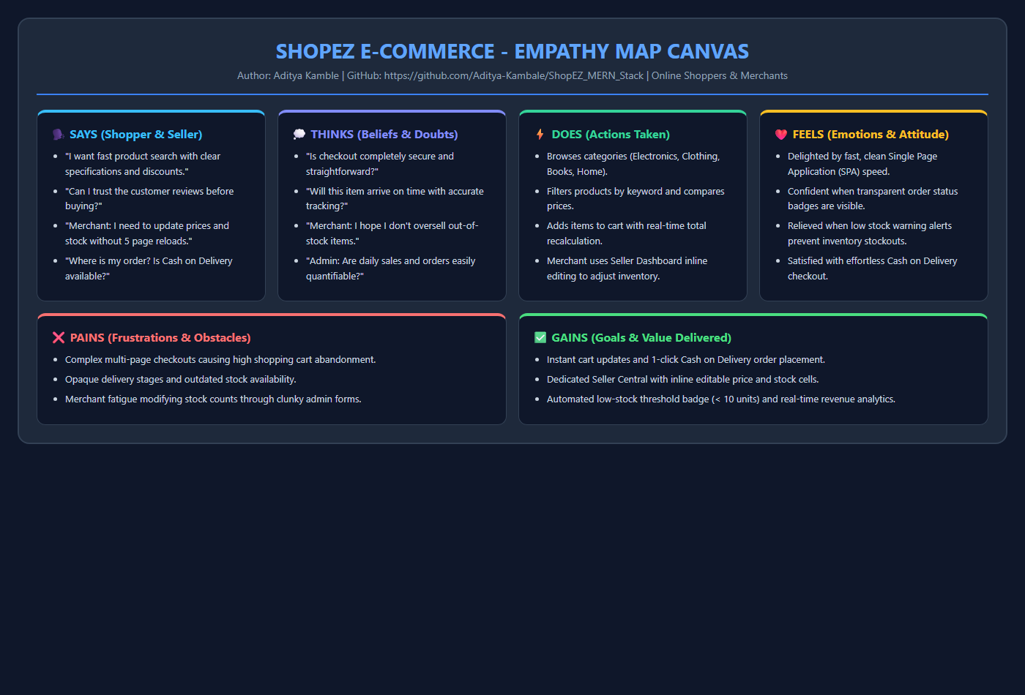
Figure 2: Empathy Map Canvas for Online Shoppers and Store Merchants

